Name :- V.Supriya
Reg no :- 192472340
Course code :- CSA1616
Course Name:- Data Warehousing and Data Mining for
Image Processing

Experiment-1
AIM:-
To find intervals and corresponding frequencies.
PROCEDURE:
- Open R/RStudio and create the age and frequency vectors.
- Enter the given age values using c() function.
- Enter the corresponding frequency values using c() function.
- Use the median() function to calculate the median of age and frequency.
- Execute the program and observe the output.
CODE:-
#age, frequency
age<-c(5,15,20,50,80,110)
frequency<-c(200,450,300,1500,700,44)
median(age)
median(frequency)
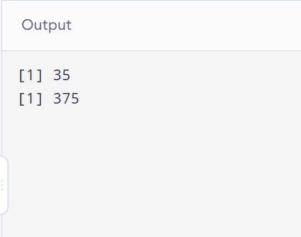
Result:- It is executed successfully.

Experiment-2
Aim:-
To find the data for analysis includes the attribute age.
Procedure:
• Open R/RStudio and create the age vector with the given values.
• Use the mean() function to calculate the mean of the age data.
• Use the median() and mode functions to find the median and mode.
• Use the range() function to find the minimum and maximum age values.
• Use quantile() to find the 25th and 75th percentiles, then observe the output.

Code:-
#mean,median,mode,quatile
age<-c(13,15,16,16,19,20,20,21,22,22,25,25,25,25,30,33,33,35,35,35,35,36,40,45,46,52,70)
mean(age)
median(age)
mode_age<-names(table(age))[table(age)==max(table(age))]
mode_age
range(age)
quantile(age,.25)
quantile(age,.75)
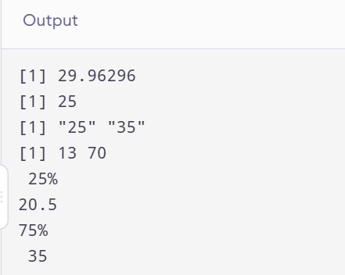
Result:- It is executed successfully.

Experiment-3
Aim:-
To show Data Preprocessing IN Reduction and Transformation .
Procedure :
- Open R/RStudio and enter the given data values.
- Set the number of bins as 5 and divide the data using the cut() function.
- Apply mean smoothing using tapply() and calculate the mean of each bin.
- Apply median smoothing using tapply() and calculate the median of each bin.
- Apply min-max smoothing to find the minimum and maximum values in each bin and observe the output.

Code:-
data <- c(11,13,13,15,15,16,19,20,20,20,21,21,22,23,24,30,40,45,45,45,71,72,73,75)
bins <- 5
bin_indices <- cut(data, bins)
mean_smooth <- tapply(data, bin_indices, mean)
print(mean_smooth)
median_smooth <- tapply(data, bin_indices, median)
median_smooth
min_max_smooth <- tapply(data, bin_indices, function(x) c(min(x), max(x)))
print(min_max_smooth)
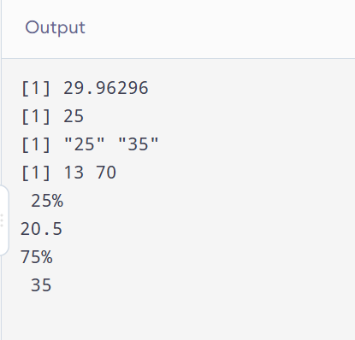
Result:- It is executed successfully.

